Lecture 7.
Nervous tissue: histogenesis, morpho-functional features.
Neurons. Glial cells.
Nerve fibers. Peculiarities of formation and conduction of nerve impulses.
Modern views on nervous tissue.
Nervous system: development, general morpho-functional features.
Spinal cord.
Brain stem.
Cerebellum.
Cerebral hemispheres. Module organization of cerebral cortex.
Autonomic nervous system.
The blood-brain barrier.

Nervous tissue, composed of as many as a trillion neurons with multitudes of interconnections, forms the complex system of neuronal communication within the body. Certain neurons have receptors, elaborated on their terminals, that are specialized for receiving different types of stimuli (e.g., mechanical, chemical, thermal) and transducing them into nerve impulses that may eventually be conducted to nerve centers. These impulses are then transferred to other neurons for processing and transmission to higher centers for perceiving sensations or for initiating motor responses. To accomplish these functions, the nervous system is organized anatomically into the central nervous system (CNS), which comprises the brain and spinal cord, and the peripheral nervous system (PNS). The PNS, located outside the CNS, includes cranial nerves, emanating from the brain; spinal nerves, emanating from the spinal cord; and their associated ganglia. Functionally, the PNS is divided into a sensory (afferent) component, which receives and transmits impulses to the CNS for processing, and a motor (efferent) component, which originates in the CNS and transmits impulses to effector organs throughout the body. The motor component is further subdivided as follows:
- In the somatic system, impulses originating in the CNS are transmitted directly, via a single neuron, to skeletal muscles.
- In the autonomic system, in contrast, impulses from the CNS first are transmitted to an autonomic ganglion via one neuron; a second neuron originating in the autonomic ganglion then transmits the impulses to smooth muscles, cardiac muscles, or glands.
In addition to neurons, nervous tissue contains numerous other cells, collectively called neuroglial cells, which do not receive or transmit impulses; instead, these cells support neurons in various ways.
DEVELOPMENT OF NERVOUS TISSUE. The nervous system develops from the ectoderm of the embryo in response to signaling molecules from the notochord. As the notochord develops early in embryonic life, it releases signaling molecules that induce the overlying ectoderm to form neuroepithelium, which thickens and forms the neural plate. As the margins of this plate continue to thicken, the plate buckles, forming a neural groove whose edges continue to grow toward each other until they come together, forming the neural tube. The rostral (anterior) end of this structure develops into the brain; the remaining (caudal) portion of the neural tube develops into the spinal cord. Additionally, the neural tube gives rise to the neuroglia, ependyma, neurons, and choroid plexus.
A small mass of cells at the lateral margins of the neural plate, which does not become incorporated into the neural tube, forms the neural crest cells. This group of cells begins to migrate away from the developing neural tube early in development. Once they reach their destinations, these cells eventually form many structures, including the following:
- Most of the sensory components of the PNS
- Sensory neurons of cranial and spinal sensory ganglia (dorsal root ganglia)
- Autonomic ganglia and the postganglionic autonomic neurons originating in them
- Much of the mesenchyme of the anterior head and neck
- Melanocytes of the skin and oral mucosa
- Odontoblasts (cells responsible for production of dentin)
- Chromaffin cells of the adrenal medulla
- Cells of the arachnoid and pia mater
- Satellite cells of peripheral ganglia
- Schwann cells
The cells of the nervous system are divided into two categories: neurons, which are responsible for the receptive, integrative, and motor functions of the nervous system; and neuroglial cells, which support and protect neurons.
Neurons. The cells responsible for the reception and transmission of nerve impulses to and from the CNS are the neurons. Ranging in diameter from 5 to 150 mm, neurons are among both the smallest and the largest cells in the body. Structure and Function of Neurons Neurons are composed of a cell body, dendrites, and an axon (Fig. 7.1). Most neurons are composed of three distinct parts: a cell body, multiple dendrites, and a single axon. The cell body of a neuron, also known as the perikaryon or soma, is the central portion of the cell where the nucleus and perinuclear cytoplasm are contained. Generally, neurons in the CNS are polygonal, with concave surfaces between the many cell processes, whereas neurons in the dorsal root ganglion (a sensory ganglion of the PNS) have a round cell body from which only one process exits. Cell bodies exhibit different sizes and shapes that are characteristic for their type and location. Projecting from the cell body are the dendrites, processes specialized for receiving stimuli from sensory cells, axons, and other neurons.
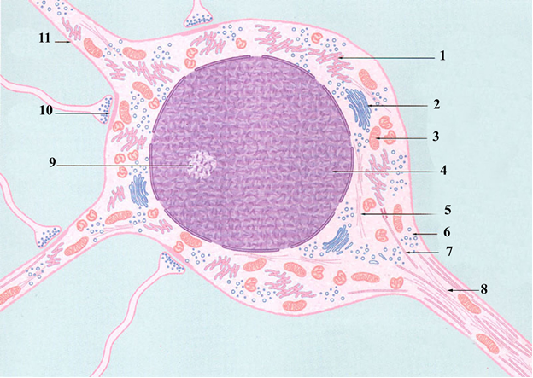

Fig. 7.1

Often the dendrites are multibranched. They are arborized so that they can receive multiple stimuli from many other neurons simultaneously. The nerve impulses received by the dendrites are then transmitted toward the soma. Each neuron possesses a single axon, a process of varying diameter and up to 100 cm in length, which usually has terminal dilatations, known as axon terminals, at or near its end. The axon conducts impulses away from the soma to other neurons, muscles, or glands, but it may also receive stimuli from other neurons, which may modify its behavior. Like dendrites, the axon arborizes. These axon terminals, also known as end bulbs (terminal boutons), approach other cells to form a synapse, the region where impulses can be transmitted between cells. Neurons can be classified according to their shape and the arrangement of their processes. Neuronal Cell Body (Soma, Perikaryon) The cell body is the region of the neuron containing the large, pale-staining nucleus and the perinuclear cytoplasm. The cell body is the most conspicuous region of the neuron, but the largest volume of the neuron's cytoplasm is located in the processes originating from the cell body. The nucleus is large, usually spherical to ovoid, and centrally located. It contains finely dispersed chromatin, indicative of a rich synthetic activity, although smaller neurons may present some condensed, inactive heterochromatin. A well-defined nucleolus is also common. The cytoplasm of the cell body has abundant rough endoplasmic reticulum (RER) with many cisternae in parallel arrays, a characteristic especially prominent in large motor neurons. Polyribosomes are also scattered throughout the cytoplasm. When these stacked RER cisternae and polyribosomes are stained with basic dyes, they appear as clumps of basophilic material called Nissl bodies, which are visible with the light microscope. RER is also present in the dendritic region of the neuron, but only as scattered short or branching cisternae. RER is absent at the axon hillock, the region on the cell body where the axon arises; however, smooth endoplasmic reticulum (SER) is present in the axon. Although Nissl bodies in each type of neuron have a characteristic size, shape, and form, no pattern has been observed. Generally, small neurons display small granular Nissl bodies, but not all large neurons display larger Nissl bodies. These differences may be related to changing physiological and pathological conditions within the neuron. Most neurons have abundant SER throughout the cell body; this reticulum extends into the dendrites and the axon, forming hypolemmal cisternae directly beneath the plasmalemma. These cisternae are continuous with the RER in the cell body and weave between the Nissl bodies on their way into the dendrites and axon. Although it is unclear how they function, it is known that hypolemmal cisternae sequester calcium and contain protein. These cisternae may serve as a conduit for the distribution of protein throughout the cell. Some authors theorize that transport and synaptic vesicles bud from these cisternae, but much of this issue is still unclear. A prominent juxtanuclear Golgi complex is present, composed of several closely associated cisternae exhibiting a dilated periphery, characteristic of protein-secreting cells. The Golgi complex is thought to be responsible for the packaging of neurotransmitter substances or enzymes essential for their production in the axon. Numerous mitochondria are scattered throughout the cytoplasm of the soma, dendrites, and axon, but they are most abundant at the axon terminals. Generally, the mitochondria in neurons are more slender than those in other cells, and occasionally their cristae are oriented longitudinally rather than transversely. It has been shown that neuronal mitochondria are constantly moving along microtubules in the cytoplasm. Most adult neurons display only one centriole associated with a basal body of a cilium; it possesses the 9 + 0 arrangement of microtubules. Because neurons do not undergo cell division, their centrioles are believed to be vestigial structures. INCLUSION. Inclusions located in neuronal cell bodies encompass nonliving substances such as melanin and lipofuscin pigments as well as lipid droplets. Dark brown to black melanin granules are found in neurons in certain regions of the CNS (e.g., mostly in the substantia nigra and locus ceruleus, with lesser amounts in the dorsal motor nucleus of the vagus and the spinal cord) and in the sympathetic ganglia of the PNS. The function of these granules in these various locations is unknown. However, dihydroxyphenylalanine (DOPA), or methyldopa, the precursor of this pigment, is also the precursor of the neurotransmitters dopamine and noradrenaline. It has been suggested, therefore, that melanin may accumulate as a by-product of the synthesis of these neurotransmitters. Lipofuscin, an irregularly shaped, yellowish brown pigment granule, is more prevalent in the neuronal cytoplasm of older adults and is thought to be the remnant of lysosomal enzymatic activity. Lipofuscin granules increase in number with advancing age and may even crowd the organelles and nucleus to one side in the cell, possibly affecting cellular function. It is interesting that certain cells (e.g., Purkinje cells of the cerebellar cortex) do not accumulate lipofuscin. Iron-containing pigments also may be observed in certain neurons of the CNS and may accumulate with age. Lipid droplets sometimes are observed in the neuronal cytoplasm and may be the result of faulty metabolism or from energy reserves. Secretory granules are observed in neurosecretory cells; many of them contain signaling molecules. CYTOSKELETAL COMPONENTS. When prepared by silver impregnation for visualization with light microscopy, the neuronal cytoskeleton exhibits neurofibrils (up to 2 mm in diameter) coursing through the cytoplasm of the soma and extending into the processes. Electron microscopic studies reveal three different filamentous structures: microtubules (24 nm in diameter), neurofilaments (intermediate filaments 10 nm in diameter), and microfilaments (6 nm in diameter). The neurofibrils observed with light microscopy possibly represent clumped bundles of neurofilaments, a suggestion supported by the fact that neurofilaments are stained by silver nitrate. Microfilaments (actin filaments) are associated with the plasma membrane. The microtubules in neurons are identical to those in other cells, except that the microtubule-associated protein MAP-2 is found in the cytoplasm of the cell body and dendrite, whereas MAP-3 is present only in the axon. Dendrites. Dendrites receive stimuli from other nerve cells. Dendrites are elaborations of the receptive plasma membrane of the neuron. In some neurons, however, the cell body and the proximal end of the axon may also serve in a receptive capacity. Most neurons possess multiple dendrites, each of which arises from the cell body, usually as a single, short trunk that ramifies several times into smaller and smaller branches, tapering at the ends like branches of a tree. Each kind of neuron has a characteristic dendrite branching pattern. The base of the dendrite arises from the cell body and contains the usual complement of organelles except for Golgi complexes. Farther away from the base, toward the distal end of the dendrite, many of the organelles become sparse or are absent. In the dendrites of most neurons, neurofilaments are reduced to small bundles or single filaments, which may be cross-linked to microtubules. Mitochondria, however, are abundant in dendrites. The branching of dendrites, which results in numerous synaptic terminals, permits a neuron to receive and integrate multiple, perhaps even hundreds of thousands, of impulses. Spines located on the surfaces of some dendrites permit them to form synapses with other neurons. These spines diminish with age and poor nutrition, and they may exhibit structural changes in persons with trisomy 13 and trisomy 21 (Down syndrome). Dendrites sometimes contain vesicles and transmit impulses to other dendrites. Axons. Axons transmit impulses to other neurons or effector cells, namely cells of muscle and glands. The axon arises from the cell body at the axon hillock as a single, thin process extending longer distances from the cell body than does the dendrite. In some instances, axons of motor neurons may be 1 meter or more in length. Axon thickness is directly related to conduction velocity, so that velocity increases as axon diameter increases. Although axon thickness varies, it is constant for a particular type of neuron. Some axons possess collateral branches, which arise at right angles from the axonal trunk. As the axon terminates, it may ramify, forming many small branches (terminal arbor). The axon hillock, a pyramid-shaped region of the soma, is devoid of ribosomes and is usually located on the opposite side of the soma from the dendrites. The portion of the axon from its origin to the beginning of the myelin sheath is called the initial segment. Deep to the axolemma (plasmalemma) of the initial segment is a thin, electron-dense layer whose function is not known but that resembles the layer located at the nodes of Ranvier. This area of the soma lacks RER and ribosomes but houses abundant microtubules and neurofilaments that are believed to facilitate the regulation of the axon's diameter. In some neurons, the number of neurofilaments may increase three-fold in the initial segment, whereas the number of microtubules increases only slightly. It is in this initial segment, referred to as the spike trigger zone, where excitatory and inhibitory impulses are summed to determine whether propagation of an action potential is to occur. The axoplasm contains short profiles of SER and remarkably long, thin mitochondria and many microtubules; however, it lacks RER and polyribosomes. Thus, the axon relies on the soma for its maintenance. Microtubules are grouped in small bundles at the origin of the axon and in its initial segment; distally, however, they become arranged as uniformly spaced, single microtubules interspersed with neurofilaments. The plasmalemma of certain neuroglial cells forms a myelin sheath around some axons in both the CNS and the PNS, referred to as myelinated axons. Axons lacking myelin sheaths are called unmyelinated axons. Nerve impulses are conducted much faster along myelinated axons than along unmyelinated axons. In the fresh state, the myelin sheath imparts a white, glistening appearance to the axon. The presence of myelin permits the subdivision of the CNS into white matter and gray matter. In addition to impulse conduction, an important function of the axon is axonal transport of materials between the soma and the axon terminals. In anterograde transport, the direction is from the cell body to the axon terminal; in retrograde transport, the direction is from the axon terminal to the cell body. Axonal transport is crucial to trophic relationships within the axon because it is located between neurons and muscles or glands. If these relationships are interrupted, the target cells atrophy. Axonal transport occurs at three velocities: fast, intermediate, and slow. The most rapid transport (up to 400 mm/day) takes place in anterograde transport of organelles, which move more rapidly in the cytosol. In retrograde transport, the fastest speed is less than half that observed in anterograde transport, with the slowest being only about 0.2 mm/day. Axonal transport speeds between these two extremes are considered intermediate. Anterograde transport is used in the translocation of organelles and vesicles as well as of macromolecules such as actin, myosin, and clathrin and of some enzymes necessary for neurotransmitter synthesis at the axon terminals. Items returned to the cell body from the axon in retrograde transport include protein building blocks of neurofilaments, subunits of microtubules, soluble enzymes, and materials taken up by endocytosis (e.g., viruses and toxins). Additionally, small molecules and proteins destined for degradation are transported to endolysosomes of the soma. Axonal transport not only distributes materials for nerve conduction and neurotransmitter synthesis but also serves to provide and ensure general maintenance of the axon cytoskeleton. Since the 1970s, much has been learned about the nature and functioning of the neuron through study of the mechanism of axonal retrograde transport with the use of the enzyme horseradish peroxidase. When this enzyme is injected into the axon terminal, it can be detected later by histochemical techniques that mark its pathway to the cell body. In studying anterograde axonal transport, researchers inject radiolabeled amino acids into the cell body and then later determine the radioactivity at the axon terminals using autoradiography. Microtubules are important in fast anterograde transport because they exhibit a polarity, with their plus ends directed toward the axon terminal. Tubulin dimers, reaching the axoplasm via anterograde transport, are assembled onto the microtubules at their plus ends and depolymerized at their minus ends. The mechanism for anterograde transport involves kinesin, a microtubule-associated protein, because one end attaches to a vesicle and the other end interacts in a cyclical fashion with a microtubule, thus permitting the kinesin to transport the vesicle at a speed of about 3 mm/second. Dynein, another microtubule-associated protein, is responsible for moving vesicles along the microtubules in retrograde transport. Classification of Neurons Neurons are classified morphologically into three major types according to their shape and the arrangement of their processes. There are three major types of neurons (Fig. 7. 2):
- Bipolar neurons possess two processes emanating from the soma, a single dendrite and a single axon. Bipolar neurons are located in the vestibular and cochlear ganglia and in the olfactory epithelium of the nasal cavity.
- Unipolar neurons (formerly called pseudounipolar neurons) possess only one process emanating from the cell body, but this process branches later into a peripheral branch and a central branch. The central branch enters the CNS, and the peripheral branch proceeds to its destination in the body. Each of the branches is morphologically axonal and can propagate nerve impulses, although the very distal aspect of the peripheral branch arborizes and displays small dendritic ends, indicating its receptor function. Unipolar neurons develop from embryonic bipolar neurons whose processes migrate around the cell body during development and eventually fuse into a single process. During impulse transmission, the impulse passes from the dendritic (receiving) end of the peripheral process to the central process without involving the cell body. Unipolar neurons are present in the dorsal root ganglia and in some of the cranial nerve ganglia.

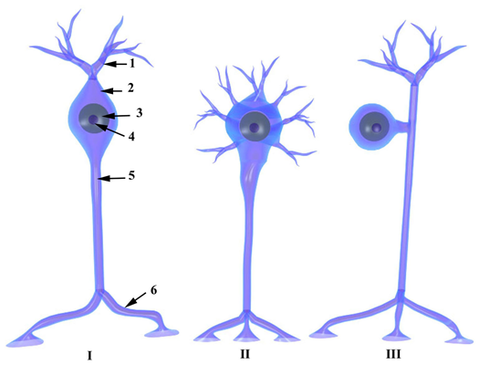

Fig. 7.2
- Multipolar neurons, the most common type, possess various arrangements of multiple dendrites emanating from the soma and a single axon. They are present throughout the nervous system, and most of them are motor neurons. Some multipolar neurons are named according to their morphology (e.g., pyramidal cells) or after the scientist who first described them (e.g., Purkinje cells).
Neurons also are classified into three general groups according to their function:
- Sensory (afferent) neurons receive sensory input at their dendritic terminals and conduct impulses to the CNS for processing. Those located in the periphery of the body monitor changes in the environment, and those within the body monitor the internal environment.
- Motor (efferent) neurons originate in the CNS and conduct their impulses to muscles, glands, and other neurons.
- Interneurons, located completely in the CNS, function as interconnectors or integrators that establish networks of neuronal circuits between sensory and motor neurons and other interneurons. With evolution, the number of neurons in the human nervous system has grown enormously, but the greatest increase has involved the interneurons, which are responsible for the complex functioning of the body
Cells whose function is the metabolic and mechanical support and protection of neurons collectively form the neuroglia (Fig. 7.3). There may be as many as 10 times more neuroglial cells than neurons in the nervous system. Neuroglial cells undergo mitosis, whereas neurons cannot-only their progenitors can. Although neuroglial cells form gap junctions with other neuroglial cells, they do not react to or propagate nerve impulses. Neuroglial cells that reside exclusively in the CNS include astrocytes, oligodendrocytes, microglia (microglial cells), and ependymal cells. Schwann cells, although located in the PNS, are now also considered neuroglial cells.

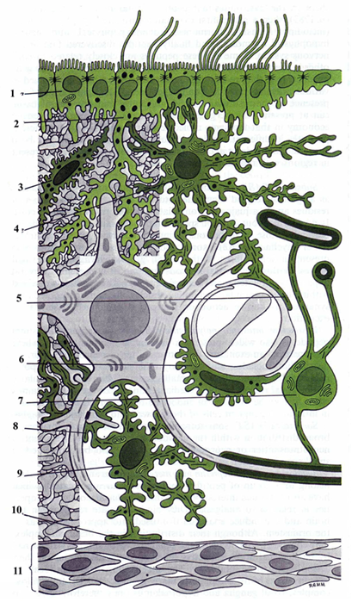

Fig. 7.3

Astrocytes. Astrocytes provide structural and metabolic support to neurons and act as scavengers of ions and neurotransmitters released into the extracellular space. Astrocytes are the largest of the neuroglial cells and exist as two distinct types: (1) protoplasmic astrocytes in the gray matter of the CNS and (2) fibrous astrocytes present mainly in the white matter of the CNS. It is difficult to distinguish the two types of astrocytes in light micrographs. Some researchers have suggested that they may be the same cells functioning in different environments. Electron micrographs display distinct cytoplasmic bundles of intermediate filaments 8- to 11-nm in diameter composed of glial fibrillar acidic protein, which is unique to astrocytes. Protoplasmic astrocytes are stellate cells displaying abundant cytoplasm, a large nucleus, and many short branching processes. The tips of some processes end as pedicels (vascular feet) that come into contact with blood vessels. Other astrocytes lie adjacent to blood vessels with the cell body apposed to the vessel wall. Still other protoplasmic astrocytes near the brain or surface of the spinal cord exhibit pedicel-tipped processes that contact the pia mater, forming the pia-glial membrane. Some smaller protoplasmic astrocytes located adjacent to neuronal cell bodies are a form of satellite cells. Fibrous astrocytes possess a euchromatic cytoplasm containing only a few organelles, free ribosomes, and glycogen. The processes of these cells are long and mostly unbranched. These processes are closely associated with the pia mater and blood vessels but are separated from these structures by their own basal lamina. Astrocytes function in scavenging ions, neurotransmitters, and remnants of neuronal metabolism, such as potassium ions (K⁺), glutamate, and γ-aminobutyric acid (GABA), accumulated in the microenvironment of the neurons, especially at the nodes of Ranvier, where they provide a cover for the axon. These cells also contribute to energy metabolism within the cerebral cortex by releasing glucose from their stored glycogen when induced by the neurotransmitters norepinephrine and vasoactive intestinal peptide. Astrocytes located at the periphery of the CNS form a continuous layer over the blood vessels and may assist in maintaining the blood-brain barrier. Astrocytes are also recruited to damaged areas of the CNS, where they form cellular scar tissue. Oligodendrocytes. Oligodendrocytes function in electrical insulation and in myelin production in the CNS. Oligodendrocytes resemble astrocytes but are smaller and contain fewer processes with sparse branching. The darkest-staining neuroglial cells, oligodendrocytes are located in both the gray and the white matter of the CNS. Their dense cytoplasm contains a relatively small nucleus, abundant RER, many free ribosomes and mitochondria, and a conspicuous Golgi complex. Microtubules also are present, especially in the perinuclear zone and in the processes. Interfascicular oligodendrocytes, located in rows beside bundles of axons, are responsible for manufacturing and maintaining myelin about the axons of the CNS, serving to insulate them. In producing myelin, oligodendrocytes function similarly to the Schwann cells of the PNS, except that a single oligodendrocyte may wrap several axons with segments of myelin, whereas a single Schwann cell wraps only one axon with myelin. Schwann cells also differ from interfascicular oligodendrocytes in the following ways: Schwann cells possess a basal lamina and retain some cytoplasm within the intracellular domains of the myelin lamellae, and connective tissue invests the myelin sheaths and their surrounding Schwann cells. Satellite oligodendrocytes are closely applied to cell bodies of large neurons; Microglial Cells Microglia are members of the mononuclear phagocyte system. Scattered throughout the CNS, microglial cells are small, dark-staining cells that faintly resemble oligodendrocytes. These cells exhibit scant cytoplasm, an oval to triangular nucleus, and irregular short processes. Spines also adorn the cell body and processes. These cells function as phagocytes in clearing debris and damaged structures in the CNS. Microglial cells also protect the nervous system from viruses, microorganisms, and tumor formation. When activated, they act as antigen-presenting cells and secrete cytokines. Unlike the other neuroglial cells, which are derived embryologically from the neural tube, microglial cells originate in the bone marrow and are part of the mononuclear phagocytic cell population. Ependymal Cells. Ependymal cells form limiting membranes and also may function in the transportation of cerebrospinal fluid. Ependymal cells (ependymocytes) are low columnar to cuboidal epithelial cells lining the ventricles of the brain and central canal of the spinal cord. They are derived from embryonic neuroepithelium of the developing nervous system. Their cytoplasm contains abundant mitochondria and bundles of intermediate filaments. In some regions, these cells are ciliated, a feature that facilitates the movement of cerebrospinal fluid (CSF). In the embryo, processes emanating from the cell body reach the surface of the brain, but in the adult the processes are reduced, ending on nearby cells. Where the neural tissue is thin, ependymal cells form an internal limiting membrane lining the ventricle and an external limiting membrane beneath the pia, both formed by thin fused pedicels. Modifications of some of the ependymal cells in the ventricles of the brain participate in the formation of the choroid plexus, which is responsible for secreting and maintaining the chemical composition of the CSF. Tanycytes, specialized ependymal cells, extend processes into the hypothalamus, where they terminate near blood vessels and neurosecretory cells. It is believed that tanycytes transport CSF to these neurosecretory cells and, possibly under control from the anterior lobe of the pituitary, may respond to changes in hormone levels in the CSF by discharging secretory products into capillaries of the median eminence.

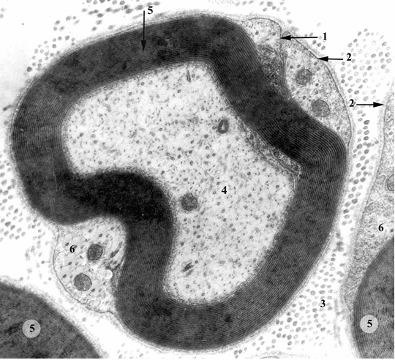

Fig. 7.4

Schwann Cells. Schwann cells form both myelinated and unmyelinated coverings over axons of the PNS. Unlike other neuroglial cells, Schwann cells are located in the PNS, where they envelop axons. They can form either myelinated or unmyelinated coverings over axons. Axons that have myelin wrapped around them are referred to as myelinated nerves (Fig. 7.4). Schwann cells are flattened cells whose cytoplasm contains a flattened nucleus, a small Golgi apparatus, and a few mitochondria. Electron microscopy has revealed that myelin is the plasmalemma of the Schwann cell organized into a sheath that is wrapped several times around the axon. Interruptions occur in the myelin sheath at regular intervals along the length of the axon, exposing the axon; these interruptions are called nodes of Ranvier . Each node indicates an interface between the myelin sheaths of two different Schwann cells located along the axon. The outer portion of Schwann cells is covered by a basal lamina that dips into the nodes of Ranvier, covering the overlapped areas of the myelin sheath lamellae of adjacent Schwann cells. Thus, each Schwann cell is covered by a basal lamina, as is the axon at the node of Ranvier. After nerve injury, the regenerating nerve is guided by the basal lamina to its location.
Areas of the axon covered by concentric lamellae of myelin and the single Schwann cell that produced the myelin are called internodal segments, which range in length from 200 to 1000 μm. Light microscopy has revealed several cone-shaped, oblique clefts in the myelin sheath of each internodal segment called clefts (incisures) of Schmidt-Lanterman. These clefts, viewed with the electron microscope, are demonstrated to be Schwann cell cytoplasm trapped within the lamellae of myelin. As the membrane spirals around the axon, it produces a series of alternating wide, dense lines with narrower, less dense lines occurring at 12-nm intervals. The wider line (3 nm in width) is known as the major dense line. It represents the fused cytoplasmic surfaces of the Schwann cell plasma membrane. The narrower intraperiod line represents the apposing outer leaflets of the Schwann cell plasma membrane. High-resolution electron microscopy has revealed small gaps within the intraperiod line between spiraled layers of the myelin sheath called intraperiod gaps. These gaps are thought to provide access for small molecules to reach the axon. The region of the intraperiod line that is in intimate contact with the axon is known as the internal mesaxon, whereas its outermost aspect, which is in contact with the body of the Schwann cell, is the external mesaxon. The mechanism of myelination, that is, the process whereby the Schwann cell located in the PNS (or oligodendrocyte, located in the CNS) concentrically wraps its membrane around the axon to form the myelin sheath, is unclear. It is believed to begin when a Schwann cell envelops an axon and somehow wraps its membrane around the axon. The wrapping may continue for more than 50 turns. During this process, the cytoplasm is squeezed back into the body of the Schwann cell, bringing the cytoplasmic surfaces of the membranes in contact with each other, thus forming the major dense line that spirals through the myelin sheath. A single Schwann cell can myelinate only one internode of a single axon (and only in the PNS), whereas oligodendrocytes can myelinate an internode of several axons (and only in the CNS). Nerves are not myelinated simultaneously during development. Indeed, the onset and completion of myelination vary considerably in different areas of the nervous system. This variation seems to be correlated with function. For example, motor nerves are nearly completely myelinated at birth, whereas sensory roots are not myelinated for several months thereafter. Some CNS nerve tracts and commissural axons are not fully myelinated until several years after birth. Some axons in the PNS are not wrapped with the many layers of myelin typical of myelinated axons. These unmyelinated axons are surrounded by a single layer of Schwann cell plasma membrane and cytoplasm of the Schwann cell. Although a single Schwann cell can myelinate only one axon, several unmyelinated axons may be enveloped by a single Schwann cell (Fig. 7.5).

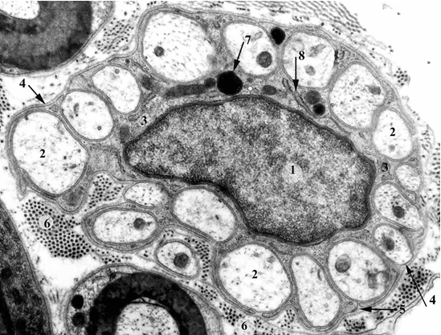

Fig. 7.5

GENERATION AND CONDUCTION OF NERVE IMPULSES. Nerve impulses are generated in the spike trigger zone of the neuron and are conducted along the axon to the axon terminal. Nerve impulses are electrical signals that are generated in the spike trigger zone of a neuron as the result of membrane depolarization and are conducted along the axon to the axon terminal. Transmission of impulses from the terminals of one neuron to another neuron, a muscle cell, or a gland occurs at synapses. Neurons and other cells are electrically polarized with a resting potential of about -90 mV (the inside of the cell being less positive than the outside) across the plasma membrane, although in smaller muscle cells and small nerve fibers, this differential may be as low as -40 to -60 mV. This potential arises because of the difference between ion concentrations inside and outside the cell. In mammalian cells, the concentration of potassium ions (K⁺) is much higher inside the cell than outside the cell, whereas the concentration of sodium ions (Na⁺) and chloride ions (Cl⁻) is much higher outside the cells than inside the cell. K⁺ leak channels in the plasmalemma permit a relatively free flow of potassium ions out of a cell down its concentration gradient. Although the K⁺ leak channel allows sodium ions to enter the cell, the ratio of potassium to sodium is 100:1, so that many more potassium ions leave the cell than sodium ions enter; thus, a small net positive charge accumulates on the outside of the plasma membrane. Although maintenance of the resting potential depends primarily on K⁺ leak channels, Na⁺-K⁺ pumps in the plasma membrane assist by actively pumping Na⁺ out of the cell and K⁺ into the cell. For every three sodium ions pumped out, two potassium ions enter the cell, also making a minor contribution to the potential difference between the two sides of the membrane. In most cells, the potential across the plasma membrane is generally constant.
In neurons and muscle cells, however, the membrane potential can undergo controlled changes, making these cells capable of conducting an electrical signal, as follows:
- 1 Stimulation of a neuron causes opening of voltage-gated Na⁺ channels in a small region of the membrane, leading to an influx of Na⁺ into the cell at that site. Eventually, the overabundance of Na⁺ inside the cell causes a reversal of the resting potential (i.e., the cytoplasmic aspect of the plasma membrane becomes positive relative to its extracytoplasmic aspect), and the membrane is said to be depolarized.
- 2 As a result, the Na⁺ channels become inactivated for 1 to 2 msec, a condition known as the refractory period. During this period the Na⁺ channels are inactive; that is, they cannot open or close and Na⁺ cannot traverse them. The presence of the refractory period is due to the specialized construction of the voltage-gated Na⁺ channels. These channels have two gates: an extracytoplasmic gate (activation gate) that opens as a result of the depolarization of the cell membrane and remains open as long as the membrane is depolarized; and an intracytoplasmic gate (inactivation gate) that closes within a few ten-thousandths of a second after the opening of the activation gate. Therefore, even though the activation gate remains open, Na⁺ can no longer enter or leave the cell through these channels.
- 3 During the refractory period, voltage-gated K⁺ channels open, permitting an efflux of K⁺ into the extracellular fluid that eventually restores the resting membrane potential; however, there may be a brief period of hyperpolarization.
- 4 Once the resting potential is restored, the voltage-gated K⁺ channels close, and the refractory period is ended with the closing of the activation gate and the opening of the inactivation gate of the voltage-gated Na⁺ channel.
The cycle of membrane depolarization, hyperpolarization, and return to the resting membrane potential is called the action potential, an all-or-none response that can occur at rates of 1000 times per second. The membrane depolarization that occurs with the opening of voltage-gated Na⁺ channels at one point on an axon spreads passively for a short distance and triggers the opening of adjacent channels, resulting in the generation of another action potential. In this manner, the wave of depolarization, or impulse, is conducted along the axon. In vivo, an impulse is conducted in only one direction, from the site of initial depolarization to the axon terminal. The inactivation of the Na⁺ channels during the refractory periods prevents retrograde propagation of the depolarization wave.
Synapses and the Transmission of the Nerve Impulse. Synapses are the sites of impulse transmission between the presynaptic and postsynaptic cells. Synapses (Fig. 7.6) are the sites where nerve impulses are transmitted from a presynaptic cell (a neuron) to a postsynaptic cell (another neuron, muscle cell, or cell of a gland). Synapses thus permit neurons to communicate with each other and with effector cells (muscles and glands). Impulse transmission at synapses can occur electrically or chemically. Although electrical synapses are uncommon in mammals, they are present in the brain stem, retina, and cerebral cortex. Electrical synapses are usually represented by gap junctions that permit free movement of ions from one cell to another. When this ion movement occurs between neurons, there is a flow of current. Impulse transmission is much faster across electrical synapses than across chemical synapses. Chemical synapses are the most common mode of communication between two nerve cells. The presynaptic membrane releases one or more neurotransmitters into the synaptic cleft, a small gap (20 to 30 nm), located between the presynaptic membrane of the first cell and the postsynaptic membrane of the second cell. The neurotransmitter diffuses across the synaptic cleft to gated ion-channel receptors on the postsynaptic membrane.

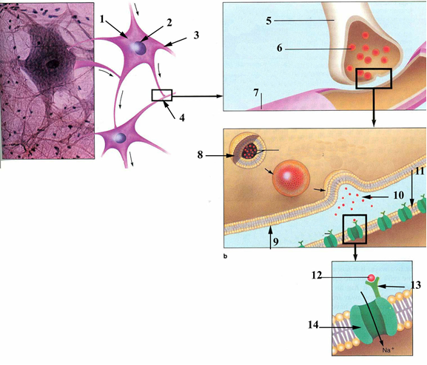

Fig. 7. 6

Binding of the neurotransmitter to these receptors initiates the opening of ion channels, which permits the passage of certain ions, altering the permeability of the postsynaptic membrane and reversing its membrane potential. Neurotransmitters do not accomplish the reaction events at the postsynaptic membrane; they only activate the response. When the stimulus at a synapse results in depolarization of the postsynaptic membrane to a threshold value that initiates an action potential, it is called an excitatory postsynaptic potential. A stimulus at the synapse that results in maintaining a membrane potential or increasing its hyperpolarization is called an inhibitory postsynaptic potential. Various types of synaptic contacts between neurons have been observed. The following synapses are the most common:
- Axodendritic synapse-between an axon and a dendrite
- Axosomatic synapse-between an axon and a soma
- Axoaxonic synapse-between two axons
- Dendrodendritic synapse-between two dendrites
Synaptic Morphology. Terminals of axons vary according to the type of synaptic contact. Often the axon forms a bulbous expansion at its terminal end called bouton terminal. Other forms of synaptic contacts in axons are derived from swellings along the axon called boutons en passage, where each bouton may serve as a synaptic site. The cytoplasm at the presynaptic membrane contains mitochondria, a few elements of SER, and an abundance of synaptic vesicles assembled around the presynaptic membrane. Synaptic vesicles are spherical structures (40 to 60 nm in diameter) filled with neurotransmitter substance that usually was manufactured and packaged near the axon terminal. Peptide neurotransmitters, however, are manufactured and packaged in the cell body and are transported to the axon terminal via anterograde transport. Enzymes located in the axoplasm protect neurotransmitters from degradation. Also located on the cytoplasmic side of the presynaptic membrane are cone-shaped densities that project from the membrane into the cytoplasm; they appear to be associated with many of the synaptic vesicles, forming the active site of the synapse. Those synaptic vesicles associated with the active site are released at stimulation. Cell adhesion molecules (CAMs) are known to play an additional role in this location as signaling molecules at both the presynaptic and postsynaptic aspects of the synapse. Other synaptic vesicles, forming a reserve pool, adhere to actin microfilaments. Synapsin-I, a small protein that forms a complex with the vesicle surface, appears to assist in the clustering of synaptic vesicles held in reserve. When synapsin-I is phosphorylated, these synaptic vesicles become free to move to the active zone in preparation for release of the neurotransmitter; dephosphorylation of synapsin-I reverses the process. Synapsin-II and rab3a, another small protein, control association of the vesicles with actin microfilaments. Docking of the synaptic vesicles with the presynaptic membrane is under control of two additional synaptic vesicle proteins: synaptotagmin and synaptophysin. When an action potential reaches the presynaptic membrane, it initiates opening of the voltage-gated calcium ion (Ca²⁺) channels, permitting Ca²⁺ to enter. This Ca²⁺ influx causes synaptic vesicles, under the influence of SNARE (SNAP receptor) proteins (including synaptobrevin, syntaxin, and soluble N-ethylmaleimide-sensitive fusion protein attachment protein-25 [SNAP-25]) to fuse with the presynaptic membrane, emptying neurotransmitter into the synaptic cleft via exocytosis. Excess membrane is recaptured via clathrin-mediated endocytosis. Recycling of synaptic vesicles involves interactions between synaptotagmin and vesicle coat protein AP-2. The endocytic vesicle fuses with the smooth endoplasmic reticulum, where new membrane is continuously recycled. It is interesting that the target protein for tetanus toxin and Clostridium botulinum neurotoxin B is synaptobrevin, the synaptic vesicle protein. Thus, these toxins selectively block synaptic vesicle exocytosis without affecting any other aspect of nerve function. The postsynaptic membrane, a thickened portion of the plasma membrane of the postsynaptic cell, contains neurotransmitter receptors, and the cytoplasmic area contains some dense material. Coupling of the neurotransmitter with the receptors in the plasmalemma initiates depolarization (an excitatory response) or hyperpolarization (an inhibitory response) of the postsynaptic membrane. Glial cells have been shown to increase synaptogenesis, synaptic efficacy, and action-potential firing. The relative thicknesses and densities of the presynaptic and postsynaptic membranes, coupled with the width of the synaptic cleft, generally correlate with the nature of the response. A thick postganglionic density and a 30-nm-wide synaptic cleft constitutes an asymmetric synapse, which is usually the site of excitatory responses. A thin postsynaptic density and a 20-nm-wide synaptic cleft constitutes a symmetric synapse, which is usually the site of inhibitory responses. Neurotransmitters. Neurotransmitters are signaling molecules that are released at the presynaptic membranes and activate receptors on postsynaptic membranes. Cells of the nervous system communicate mostly by the release of signaling molecules. The released molecules contact receptor molecules protruding from the plasmalemma of the target cell, eliciting a response from the target cell. These signaling molecules were called neurotransmitters. However, such molecules may act on two types of receptors: (1) those directly associated with ion channels and (2) those associated with G proteins or receptor kinases, which activate a second messenger. Therefore, signaling molecules that act as "first messenger systems" (i.e., act on receptors directly associated with ion channels) retain the name neurotransmitters, and signaling molecules that invoke the "second messenger system" now are referred to as neuromodulators or neurohormones. Because neurotransmitters act directly, the entire process is fast, lasting usually less than 1 msec. Events utilizing neuromodulators are much slower and may last as long as a few minutes. There are perhaps 100 known neurotransmitters (and neuromodulators), represented by the following three groups:
- Small-molecule transmitters
- Neuropeptides
- Gases
Small-molecule transmitters are of three major types:
- Acetylcholine (the only one in this group that is not an amino acid derivative)
- The amino acids: glutamate, aspartate, glycine, and γ-aminobutyric acid (GABA)
- The biogenic amines: (monoamines) serotonin and the three catecholamines: dopamine, norepinephrine (noradrenaline), and epinephrine (adrenaline).
Neuropeptides, many of which are neuromodulators, form a large group. They include:
- The opioid peptides: enkephalins and endorphins
- Gastrointestinal peptides, which are produced by cells of the diffuse neuroendocrine system: substance P, neurotensin, and vasoactive intestinal peptide
- Hypothalamic-releasing hormones, such as thyrotropin-releasing hormone and somatostatin
- Hormones stored in and released from the neurohypophysis (antidiuretic hormone and oxytocin).
Gases may act as neuromodulators. The ones that do are nitric oxide (NO) and carbon monoxide (CO). Several principles appear to describe the functioning of neurotransmitters. First, a specific neurotransmitter may elicit different actions under varied circumstances. Second, the nature of the postsynaptic receptors determines the effect of a neurotransmitter on postsynaptic cells. Synaptic communication commonly involves multiple neurotransmitters. Additionally, there is mounting evidence for volume transmission as a method of communication between brain cells. According to this concept, chemical and electrical "neurotransmitters," believed to exist in the intercellular fluid-filled spaces between brain cells, activate groups or fields of cells that contain appropriate receptors rather than individual cells. Whereas synaptic communication is fast-acting, volume transmission is thought to be slow and may be related to such conditions as autonomic function, alertness, awareness, changes in brain patterns during sleep, sensitivity to pain, and moods. Peripheral nerves are bundles of nerve fibers (axons), located outside the central nervous system and surrounded by several investments of connective tissue sheaths (Fig. 7. 7). These bundles (fascicles) may be observed with the unaided eye; those that are myelinated appear white because of the presence of myelin. Usually, each bundle of nerve fibers, regardless of size, has both sensory and motor components.

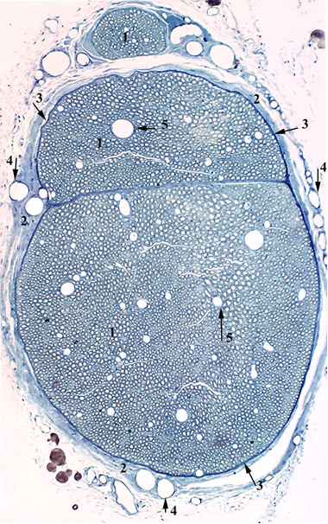

Fig. 7.7

Connective Tissue Investments. Connective tissue investments of peripheral nerves include the epineurium, perineurium, and endoneurium. Epineurium is the outermost layer of the three connective tissue investments covering nerves. The epineurium is composed of dense, irregular, collagenous connective tissue containing thick elastic fibers that completely ensheathe the nerve. Collagen fibers within the sheath are aligned and oriented to prevent damage by overstretching of the nerve bundle. The epineurium is thickest where it is continuous with the dura covering the CNS at the spinal cord or brain, where the spinal or cranial nerves originate, respectively. The epineurium becomes progressively thinner as the nerves branch into smaller nerve components, eventually disappearing. Perineurium, the middle layer of connective tissue investments, covers each bundle of nerve fibers (fascicle) within the nerve. The perineurium is composed of dense connective tissue but is thinner than epineurium. Its inner surface is lined by several layers of epithelioid cells joined by zonulae occludentes and surrounded by a basal lamina that isolates the neural environment. Between the layers of epithelioid cells are sparse collagen fibers oriented longitudinally and intertwined with a few elastic fibers. The thickness of the perineurium is progressively reduced to a sheet of flattened cells. Endoneurium, the innermost layer of the three connective tissue investments of a nerve, surrounds individual nerve fibers (axons). A loose connective tissue composed of a thin layer of reticular fibers (produced by the underlying Schwann cells), scattered fibroblasts, fixed macrophages, capillaries, and perivascular mast cells in extracellular fluid, the endoneurium is in contact with the basal lamina of the Schwann cells. Thus, the endoneurium is housed in a compartment completely isolated from the perineurium and Schwann cells, an important factor in regulation of the microenvironment of the nerve fiber. Near the distal terminus of the axon, the endoneurium is reduced to a few reticular fibers surrounding the basal lamina of the Schwann cells of the axon. Functional Classification of Nerves Functionally, nerve fibers are classified as sensory (afferent) or motor (efferent). Nerve fibers are segregated functionally into sensory (afferent) fibers and motor (efferent) fibers. Sensory nerve fibers carry sensory input from the cutaneous areas of the body and from the viscera back to the CNS for processing. Motor nerve fibers originate in the CNS and carry motor impulses to the effector organs. The sensory roots and motor roots of the spinal cord unite to form mixed peripheral nerves, the spinal nerves, which carry both sensory and motor fibers.
Conduction Velocity The conduction velocity of peripheral nerve fibers depends on the extent of their myelination. In myelinated nerves, ions can cross the axonal plasma membrane, initiating depolarization, only at the nodes of Ranvier, for two reasons:
- 1 Voltage-gated Na⁺ channels of the axon plasmalemma are clustered mostly at the nodes of Ranvier.
- 2 The myelin sheath covering the internodes prevents the outward movement of the excess Na⁺ in the axoplasm associated with the action potential
Therefore, the excess positive ions can diffuse only through the axoplasm to the next node, triggering depolarization there. In this way, the action potential "jumps" from node to node, a process called saltatory conduction. As noted earlier, unmyelinated fibers lack a thick myelin sheath and nodes of Ranvier. These fibers are surrounded by a single layer of Schwann cell plasma membrane and cytoplasm, which provides little insulation. Moreover, voltage-gated Na⁺ channels are distributed along the entire length of the axon plasma membrane. Therefore, impulse propagation in unmyelinated fibers occurs by continuous conduction, which is slower and requires more energy than the saltatory conduction occurring in myelinated fibers.
Peripheral nerve fibers are classified into three major groups according to their conduction velocity. In thin unmyelinated fibers, the conduction velocity ranges from about 0.5 to 2 m/sec, whereas in heavily myelinated fibers, it ranges from 15 to 120 m/sec.
Autonomic Nervous System Autonomic nerves provide motor innervation to smooth muscle and cardiac muscle and supply secretomotor innervation to glands. The autonomic (involuntary, visceral) nervous system is generally defined as a motor system; although agreement on this point is not universal, it is regarded as a motor system in this discussion. The autonomic nervous system controls the viscera of the body by supplying the general visceral efferent (visceral motor) component to smooth muscle, cardiac muscle, and glands. In contrast to the somatic system, in which one neuron originating in the CNS acts directly on the effector organ, the autonomic nervous system possesses two neurons between the CNS and the effector organ. Cell bodies of the first neurons in the chain lie in the CNS and their axons are usually myelinated. These preganglionic fibers (axons) seek an autonomic ganglion located outside the CNS, where they synapse on multipolar cell bodies of postganglionic neurons. Postganglionic fibers, which are usually unmyelinated although they always are enveloped by Schwann cells, exit the ganglion to terminate on the effector organ (smooth muscle, cardiac muscle, gland). Also unlike the somatic system, the autonomic system has postganglionic synapses that branch out, and the neurotransmitter diffuses out for some distance to the effector cells, thus contributing to more prolonged and widespread effects than in the somatic system. Smooth muscle cells stimulated by the neurotransmitter activate adjacent smooth muscle cells to contract by relaying the information via gap junctions. The autonomic nervous system is subdivided into two functionally different divisions:
- In general, the sympathetic nervous system prepares the body for action by increasing respiration, blood pressure, heart rate, and blood flow to the skeletal muscles, dilating pupils of the eyes and generally slowing down visceral function.
- The parasympathetic nervous system tends to be functionally antagonistic to the sympathetic system in that it decreases respiration, blood pressure, and heart rate, reduces blood flow to skeletal muscles, constricts the pupils, and generally increases the actions and functions of the visceral system.
Thus, the parasympathetic nervous system brings about homeostasis, whereas the sympathetic nervous system prepares the body for "fight or flight". The sympathetic nervous system is broadly considered to function in vasoconstriction, whereas the parasympathetic nervous system is broadly considered to be secretomotor in function. Because the visceral components of the body receive innervation from both divisions of the autonomic nervous system, these two systems are balanced in health. Acetylcholine is the neurotransmitter at all synapses between preganglionic and postganglionic fibers and between parasympathetic postganglionic endings and effector organs. Norepinephrine is the neurotransmitter at synapses between postganglionic sympathetic fibers and effector organs. Generally, preganglionic fibers of the sympathetic system are short but postganglionic fibers are long. In contrast, preganglionic fibers of the parasympathetic system are long, whereas postganglionic fibers are short. Sympathetic Nervous System The effect of the sympathetic nervous system is to prepare the body for "flight or fight."
The sympathetic nervous system originates in the spinal cord from segments of the thoracic spinal cord and upper lumbar spinal cord (T1 to L2). Thus, the sympathetic nervous system is sometimes called the thoracolumbar outflow. Cell bodies of preganglionic neurons are small, spindle-shaped cells that originate in the lateral horn of the spinal cord; their axons exit the cord via the ventral roots to join the spinal nerve. After a short distance, the fibers leave the peripheral nerve, via white rami communicantes, to enter one of the paravertebral chain ganglia. Typically, the preganglionic neuron either synapses on a cell body of one of the multipolar postganglionic neurons residing in the ganglion associated with that spinal cord segment or ascends or descends in the sympathetic trunk to synapse on a cell in another of the chain ganglia. However, certain preganglionic fibers do not synapse in the chain ganglia; instead, they pass through to enter the abdominal cavity as splanchnic nerves. Here they seek collateral ganglia located along the abdominal aorta for synapsing on cell bodies of postganglionic fibers residing there. Axons of postganglionic neurons housed in the chain ganglia exit the ganglia, via gray rami communicantes, to reenter the peripheral nerve for distribution to effector organs in the periphery (i.e., sweat glands, blood vessels, dilator pupillae muscles, cardiac muscle, bronchial tree, salivary glands, and arrector muscles of hair). Axons of postganglionic neurons housed in the collateral ganglia exit the ganglia and accompany the myriad blood vessels to the viscera, where they synapse on the effector organs (i.e., blood vessels and the smooth muscles and glands of the viscera).

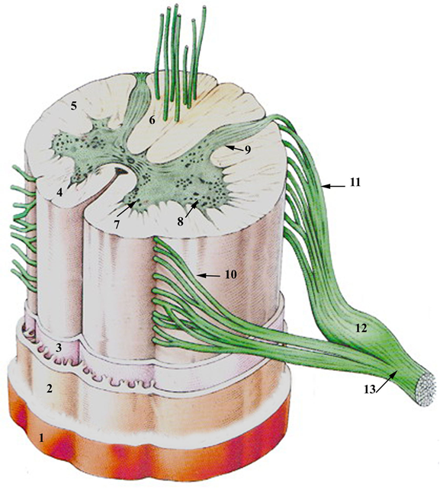

Fig. 7. 8

Parasympathetic Nervous System The effect of the parasympathetic nervous system is to prepare the body to "rest or digest." The parasympathetic nervous system originates in the brain and the sacral segments of the spinal cord (S2 to S4); thus, the parasympathetic system is called the craniosacral outflow. Cell bodies of preganglionic parasympathetic neurons originating in the brain lie in the visceromotor nuclei of the four cranial nerves that carry visceral motor components (cranial nerves III, VII, IX, and X). Axons of preganglionic parasympathetic fibers of cranial nerves III, VII, and IX seek parasympathetic (terminal) ganglia located outside the brain case, where they synapse on cell bodies of postganglionic parasympathetic neurons housed in the ganglia. Axons of these nerves are usually delivered by cranial nerve V to the effector organs they serve, including salivary glands and mucous glands, whereas cranial nerve III delivers postganglionic parasympathetic fibers to the ciliary muscle and the sphincter pupillae muscles of the eye. Axons of preganglionic parasympathetic fibers in cranial nerve X travel to the thorax and abdomen before synapsing in the terminal ganglia within the respective viscera. Axons of postganglionic parasympathetic nerves synapse on the glands, smooth muscles, and cardiac muscle. Cell bodies of preganglionic parasympathetic nerves originating in segments of the sacral spinal cord are located in the lateral segment of the ventral horn and leave via the ventral root with the sacral nerves. From here, the axons project to terminal ganglia (Meissner's and Auerbach's plexuses) in the walls of the lower gastrointestinal tract, where they synapse on cell bodies of postganglionic parasympathetic neurons. Axons of postganglionic neurons synapse on the effector organs in the viscera of the lower abdominal wall and the pelvis.
CENTRAL NERVOUS SYSTEM. The CNS, composed of the brain and the spinal cord (Fig. 7.8), consists of white matter and gray matter without intervening connective tissue elements; therefore, the CNS has the consistency of a semifirm gel. White matter is composed mostly of myelinated nerve fibers along with some unmyelinated fibers and neuroglial cells; its white color results from the abundance of myelin surrounding the axons. Gray matter consists of aggregations of neuronal cell bodies, dendrites, and unmyelinated portions of axons as well as neuroglial cells; the absence of myelin causes these regions to appear gray in live tissue. Axons, dendrites, and neuroglial processes form a tangled network of neural tissue called the neuropil. In certain regions, aggregations of neuron cell bodies embedded in white matter are called nuclei, whereas their counterparts in the peripheral nervous system are called ganglia. Gray matter in the brain is located at the periphery (cortex) of the cerebrum and cerebellum and forms the deeper basal ganglia, whereas the white matter lies deep to the cortex and surrounds the basal ganglia. The reverse is true in the spinal cord; white matter is located in the periphery of the spinal cord, whereas gray matter lies deep in the spinal cord, where it forms an H shape in cross section. A small central canal, lined by ependymal cells and representing the lumen of the original neural tube, lies in the center of the crossbar of the H. The upper vertical bars of the H represent the dorsal horns of the spinal cord, which receive central processes of the sensory neurons whose cell bodies lie in the dorsal root ganglion. Cell bodies of interneurons are also located in the dorsal horns. Cell bodies of interneurons (internuncial neurons or intercalated neurons) originate in the CNS and are entirely confined there, where they form networks of communication for integration between sensory and motor neurons. Interneurons constitute the vast majority of the neurons of the body. The lower vertical bars of the H represent the ventral horns of the spinal cord, which house cell bodies of large multipolar motor neurons whose axons exit the spinal cord via the ventral roots.
Blood-Brain Barrier. Endothelial cells of CNS capillaries prevent the free passage of selective blood-borne substances into the neural tissue. A highly selective barrier, known as the blood-brain barrier, exists between specific blood-borne substances and the neural tissue of the CNS. This barrier is established by the endothelial cells lining the continuous capillaries that course through the CNS. These endothelial cells form fasciae occludentes with one another, retarding the flow of materials between cells. Additionally, these endothelial cells have relatively few pinocytotic vesicles, and vesicular traffic is almost completely restricted to receptor-mediated transport. Macromolecules injected into the vascular system cannot enter the intercellular spaces of the CNS; conversely, macromolecules injected into the intercellular spaces of the CNS cannot enter the capillary lumen. Certain substances, however, such as oxygen, water, and carbon dioxide, and other small, lipid-soluble materials, including some drugs, can easily penetrate the blood-brain barrier. Molecules such as glucose, amino acids, certain vitamins, and nucleosides are transferred across the blood-brain barrier by specific carrier proteins, many via facilitated diffusion. Ions are also transported across the blood-brain barrier through ion channels via active transport. The energy requirement for this process is satisfied by the presence of large numbers of mitochondria within the endothelial cell cytoplasm. Capillaries of the CNS are invested by well-defined basal laminae, which in turn are almost completely surrounded by the end-feet of numerous astrocytes, collectively called the perivascular glia limitans. It is believed that these astrocytes help convey metabolites from blood vessels to neurons. Additionally, astrocytes remove excess K⁺ and neurotransmitters from the neuron's environment, thus maintaining the neurochemical balance of the CNS extracellular milieu.

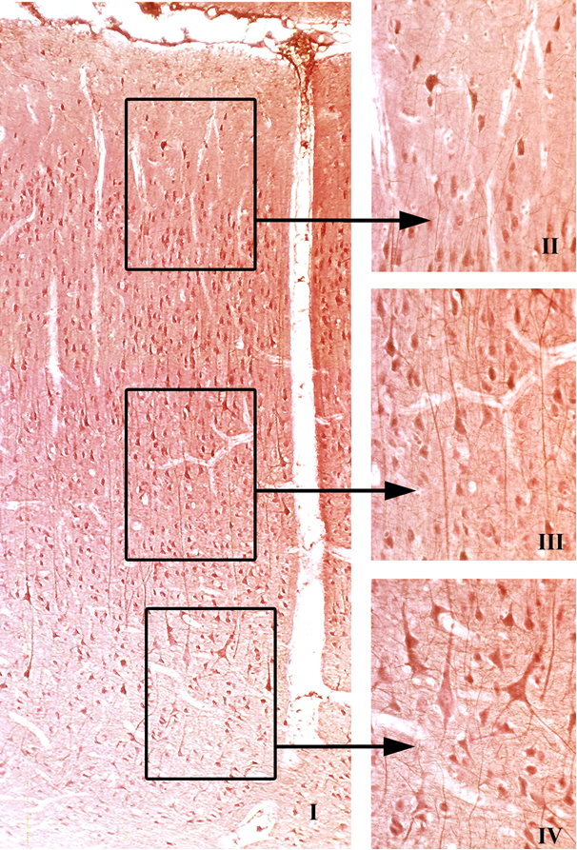

Fig. 7.9

Cerebral Cortex (Fig. 7.9). The cerebral cortex is responsible for learning, memory, sensory integration, information analysis, and initiation of motor responses. Gray matter at the periphery of the cerebral hemispheres is folded into many gyri and sulci called the cerebral cortex. This portion of the brain is responsible for learning, memory, information analysis, initiation of motor response, and integration of sensory signals.
The cerebral cortex is divided into six layers composed of neurons that exhibit a morphology unique to the particular layer. The most superficial layer lies just deep to the pia mater; the sixth, or deepest, layer of the cortex is bordered by white matter of the cerebrum. The six layers and their components are as follows:
- 1 The molecular layer is composed mostly of nerve terminals originating in other areas of the brain, horizontal cells, and neuroglia.
- 2 The external granular layer contains mostly granule (stellate) cells and neuroglial cells.
- 3 The external pyramidal layer contains neuroglial cells and large pyramidal cells, which become increasingly larger from the external to the internal border of this layer.
- 4 The internal granular layer is a thin layer characterized by closely arranged, small granule cells (stellate cells), pyramidal cells, and neuroglia. This layer has the greatest cell density of the cerebral cortex.
- 5 The internal pyramidal layer contains the largest pyramidal cells and neuroglia. This layer has the lowest cell density of the cerebral cortex.
- 6 The multiform layer consists of cells of various shapes (Martinotti cells), and neuroglia.
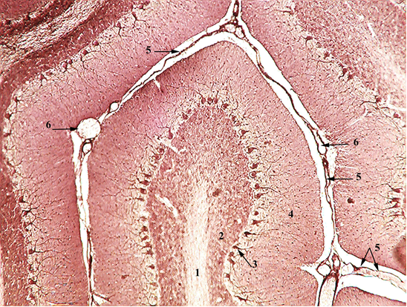

Fig. 7. 10
Cerebellar Cortex (Fig. 7.10). The cerebellar cortex is responsible for balance, equilibrium, muscle tone, and muscle coordination. The layer of gray matter located in the periphery of the cerebellum is called the cerebellar cortex: This portion of the brain is responsible for maintaining balance and equilibrium, muscle tone, and coordination of skeletal muscles. Histologically, the cerebellar cortex is divided into three layers:
- 1 The molecular layer lies directly below the pia mater and contains superficially located stellate cells, dendrites of Purkinje cells, basket cells, and unmyelinated axons from the granular layer.
- 2 The Purkinje cell layer contains the large, flask-shaped Purkinje cells, which are present only in the cerebellum. Their arborized dendrites project into the molecular layer, and their myelinated axons project into the white matter. Each Purkinje cell receives hundreds of thousands of excitatory and inhibitory synapses that it must integrate to form the proper response. The Purkinje cell is the only cell of the cerebellar cortex that sends information to the outside, and it is always an inhibitory output using GABA as the neurotransmitter.
- 3 The granular layer (the deepest layer) consists of small granule cells and glomeruli (cerebellar islands). Glomeruli are regions of the cerebellar cortex where synapses are taking place between axons entering the cerebellum and the granule cells.

